WESTERN ILLINOIS BUILDERS ASSOCIATION
40th ANNUAL HOME SHOW
 MARCH 4th – 5th 2017 

Western Illinois Builders Association sponsors a Home Show in the Sandburg Mall in Galesburg the first weekend in March. It is a great advertising tool as well as a way to show the public your specialty and promote any new ideas in your specific field. Side Court & Center Court booths will be available. Any participant in last year’s Home Show that would like the same spot must have their booth paid for by January 13th, 2017 or that spot may be given to someone else. In order to participate, you must be a member of Western Illinois Builders Association. Yearly membership fee is $150. Membership fees & final booth rental must be paid by Wednesday, February 10, 2017. Send it in by November 30th and receive $20 in WIBA Swag Bucks for the WIBA Christmas Party.

If you are interested in the Home Show or in Western Illinois Builders Association & would like more information or wish to reserve a booth, please complete the form below & return to WIBA.

First time participants receive $100 off booth rental. Members who have attended 5 meetings during the past year can deduct $100 from their booth rental (One per exhibitor please). Any member who brings a new exhibitor for the Home Show gets $25 off their booth.

Each Booth Space is 10’X10’
Please check one or number if more than one space needed.
Fees = $250 for Side Court____$275 for Center Court____

2017 HOME SHOW RESERVATION 
NAME ______________________________ COMPANY _____________________________

TYPE of BUSINESS __________________________________________________________

ADDRESS ___________________________________________________________________

PHONE ______________ FAX _______________ E-MAIL ADDRESS_______________

Please circle booth preference: Center Court Corner Side Court
Number of booths requested: ______
Please check here if you would like more information about:
Home Show _____ Western Illinois Builders Association _____
*Note Change this year- Please mail form with FEES payable to WIBA:
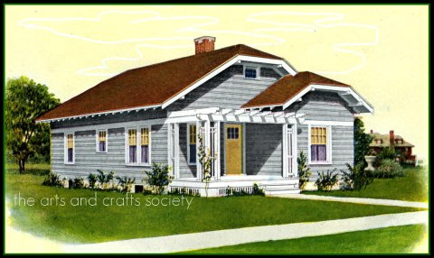
WIBA
PO BOX 565
Galesburg, IL. 61402-0565 Questions? PHONE: 309-343-2116

