WESTERN ILLINOIS BUILDERS ASSOCIATION

ANNUAL HOME SHOW
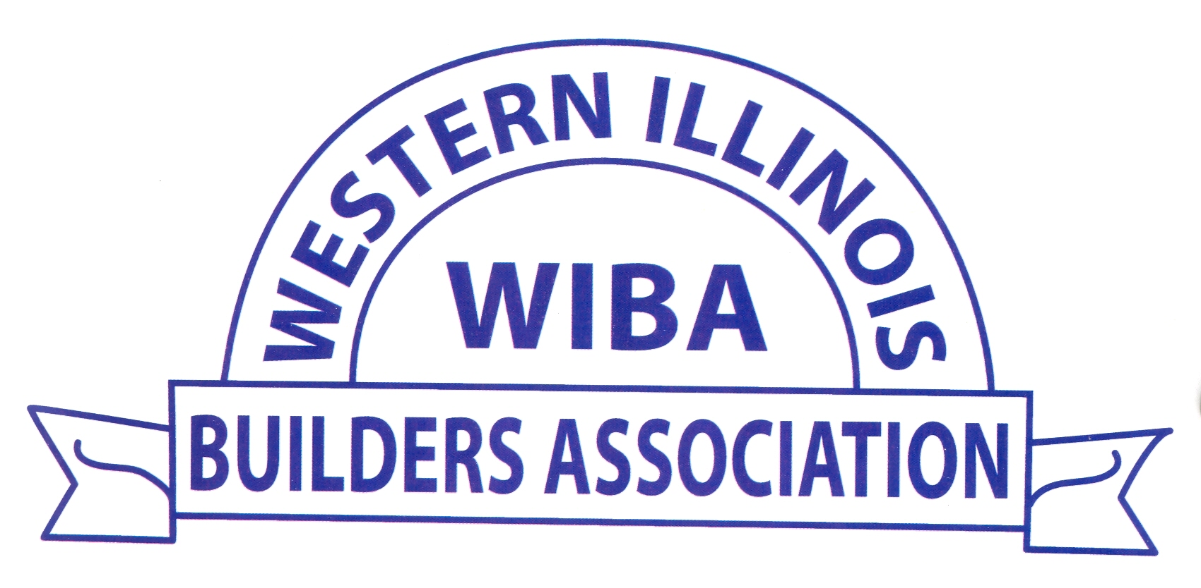 March 26th 10a.m.-4p.m. & March 27th 12-4p.m. 

For WIBA Members

Knights of Columbus 1556 E. Fremont St. in Galesburg

Full menu available for purchase/ No outside food or drink

Vendors should park in the back.

It is a great advertising too
to show the public your specialty &
promote any new ideas in your specific field.

First time participants receive- $100 discount
Set Up
Friday, March 25th
1p.m.-6p.m.
Attend 5 meetings- $100 discount
Bring a new exhibitor- $25 discount
One discount per exhibitor.

Each Booth Space Indoors is 8’X10’.
Each Booth Outside is 10’X10’and can be inside a tent.
Set Up is on Friday, April 25th from 1-6p.m. or on Saturday from 8a.m.-9:30a.m.
- - - - - - - - - - - - - - - - -- - - - - - - - - -- - -- -- --- - - - - -- - - - - -- - - - - - - - - - - - -- - - - -- -- -- - - - -- - ---
2022 HOME SHOW RESERVATIONS

NAME ______________________________ COMPANY _____________________________

TYPE of BUSINESS __________________________________________________________

ADDRESS ___________________________________________________________________

PHONE ______________ FAX _______________ E-MAIL ADDRESS_______________

Please check one or number if more than one space needed.
Fees = $275 for Inside ____ I need electricity. ___I need a table. ____ I need a tablecloth. ___
$250 for Outside____ I need a table. ____ I need a tablecloth. _____
Yearly membership fee is $150.

Membership fees & final booth rental must be paid by Wednesday, March 16, 2022.
Please mail form with FEES payable to WIBA: 
WIBA
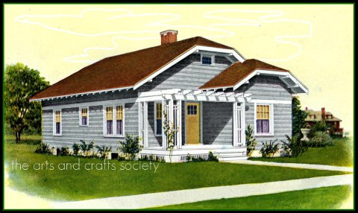
PO BOX 565 Galesburg, IL. 61402-0565 Questions? PHONE: 309-343-2116

