WESTERN ILLINOIS BUILDERS ASSOCIATION

 Saturday, March 25^{h} 10a.m.-4p.m. 

Knights of Columbus 1556 E. Fremont St. in Galesburg

Full menu available for purchase/ No outside food or drink

Vendors should park in the back.

It is a great advertising tool to show the public your specialty &
promote any innovative ideas in your specific field.
Set Up
Inside booths- Friday, March 24th 1-6p.m.
Outside booths- Saturday March 25th before the show
First time participants receive a $100 discount.
Bring a new exhibitor receive a $50 discount.
One discount per exhibitor.

Each Booth Space Indoors is 8’X10’.
Each Booth Outside is 10’X10’and can be inside a tent.
- - - - - - - - - - - - - - - - -- - - - - - - - - -- - -- -- --- - - - - -- - - - - -- - - - - - - - - - - - -- - - - -- -- -- - - - -- - ---
2023 HOME SHOW RESERVATIONS

NAME ______________________________ COMPANY _____________________________

TYPE of BUSINESS __________________________________________________________

ADDRESS ___________________________________________________________________

PHONE ______________ FAX _______________ E-MAIL ADDRESS_______________

I will donate for a door prize; ___________________________________________________.

Number of Spaces Wanted; ___.
Fees: $275 for Inside ____ I need electricity. ___I need a table. ____ I need a tablecloth. ___
$250 for Outside ___ I need a table. ____ I need a tablecloth. ___ (I can set up the morning of the show.) __
I am sending my check in by February 25th so deduct $100 from my Home Show fee. __
I have recruited________________ and they have paid for the membership & Home Show fee $50 discount. __
Yearly membership fee is $150. ___
Membership fees & final booth rental must be paid by Wednesday, March 10, 2023.
Total Amount Due $________
Check Number _________
Date _________
Please mail form with FEES payable to WIBA: 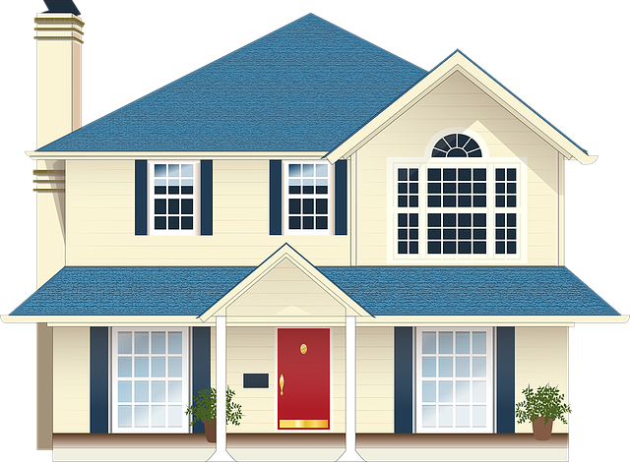
WIBA PO BOX 565 Galesburg, IL. 61402-0565 Questions? PHONE: 309-343-2116

